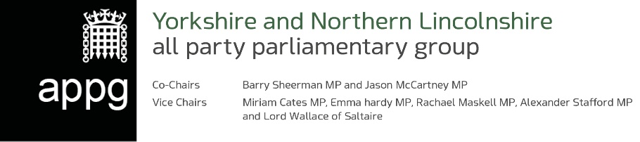

Period covered by this statement: 3rd February 2024 to 30th May 2024

A. Balance brought forward from previous year: | £23,050.48
B. Income received during the year:
i. Membership subscriptions (parliamentarians) | £0
ii. Monetary donations (including external subscriptions and sponsorship) | £0
iii. Trading income | £0
iv. Interest received | £0
v. Other (please explain) | £0

TOTAL income | £0
C. Expenditure during the year:
i. Employment costs (salaries, NI, pensions costs ) | £0
ii. Costs of contractors and freelance staff | £3,368.88
iii. Visits and events (UK) | £0
iv. Visits and events (abroad) | £0
v. Cost of generating income | £0
vi. Office and communications costs | £0
vii. Other (please explain)
TOTAL expenditure | £3,368.88
D. Balance carried forward ( A+ total B-total C) | £19,681,60
E. Value of benefits in kind received from each source during the reporting year (in bands of up to £1,500; £1,501-£3,000; £3,001 to £4,500; £4,501 to £6,000 etc )  Please itemise according to the source and band | £0
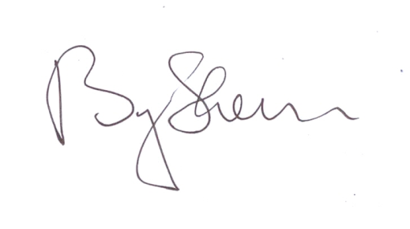

Signed by Chair of Group:
Barry Sheerman MP

Date: 30/05/2024

