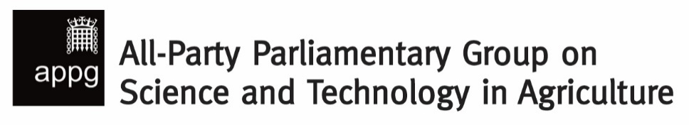

Inaugural Meeting

Key priorities for UK agricultural science and innovation to deliver for food security, climate and nature

Monday 11 November 2024, 5.30 – 6.30pm
Macmillan Room, Portcullis House

AGENDA

1. Chair-elect’s welcome – George Freeman MP

2. Confirmation of All-Party Group’s purpose and remit
“To provide a forum for parliamentarians and stakeholders to debate and highlight the value of science and technology in agriculture.”

3. Election of chair and officers

4. Role of co-ordinator and proposed new core stakeholder

5. Chair’s introduction

6. Guest speakers
Dr Helen Ferrier, Chief Science Adviser, NFU
Josh Woolliscroft, Head of External Affairs, CropLife UK
Ed Barker, Head of Policy, Agricultural Industries Confederation (AIC)
Professor Mario Caccamo, Chief Executive, NIAB
Dr Anthony Hopkins, Head of Policy, British Society of Plant Breeders (BSPB)

7. Questions & discussion

8. A.O.B.

