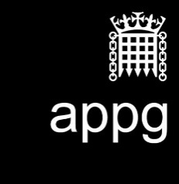

**All-Party Parliamentary Media Group**

**Income and expenditure statement 2018/19**

**Name of Group:** All-Party Parliamentary Media Group

**Period covered by this statement:** 30 June 2018 – 29 June 2019

1. **Balance brought forward from previous year:** £0.00
2. **Income received during the year**
3. Membership subscriptions (parliamentarians): £0.00
4. Monetary donations (including external subscriptions and sponsorship: £0.00
5. Trading income: £0.00
6. Interest received: £0.00
7. Other (please explain): N/A

**Total income: £0.00**

1. **Expenditure during the year**
2. Employment costs (salaries, NI, pensions, costs): £0.00
3. Costs of contractors and freelance staff: £0.00
4. Visits and events (UK): £0.00
5. Visits and events (abroad): £0
6. Cost of generating income: £0.00
7. Office and communication costs: £0
8. Other (please explain): N/A

**Total expenditure**

1. **Balance carried forward (A + total B – total C):** £0.00

1. **Value of benefits in kind received from each source during the reporting year**

**(in bands of up to £1,500; £1,501-£3,000; £3,001-£4,500 etc.): N/A**

**Please itemise according to the source and band**

Band £17,501-£19,500: Provision of secretariat support from The Whitehouse Consultancy

Band £11,501-£13,000: Cost and management of All-Party Parliamentary Media Group annual reception

The Whitehouse Consultancy is sponsored £29,500 for the provision of secretariat support by Arqiva, BT, Camelot, Discovery International, Global, News Now, News UK, Screen Skills, UKTV, and Viacom. The above sponsorship also meets the event costs of the All-Party Parliamentary Media Group’s annual reception.

**Signed by Chair of Group**

**Date:**