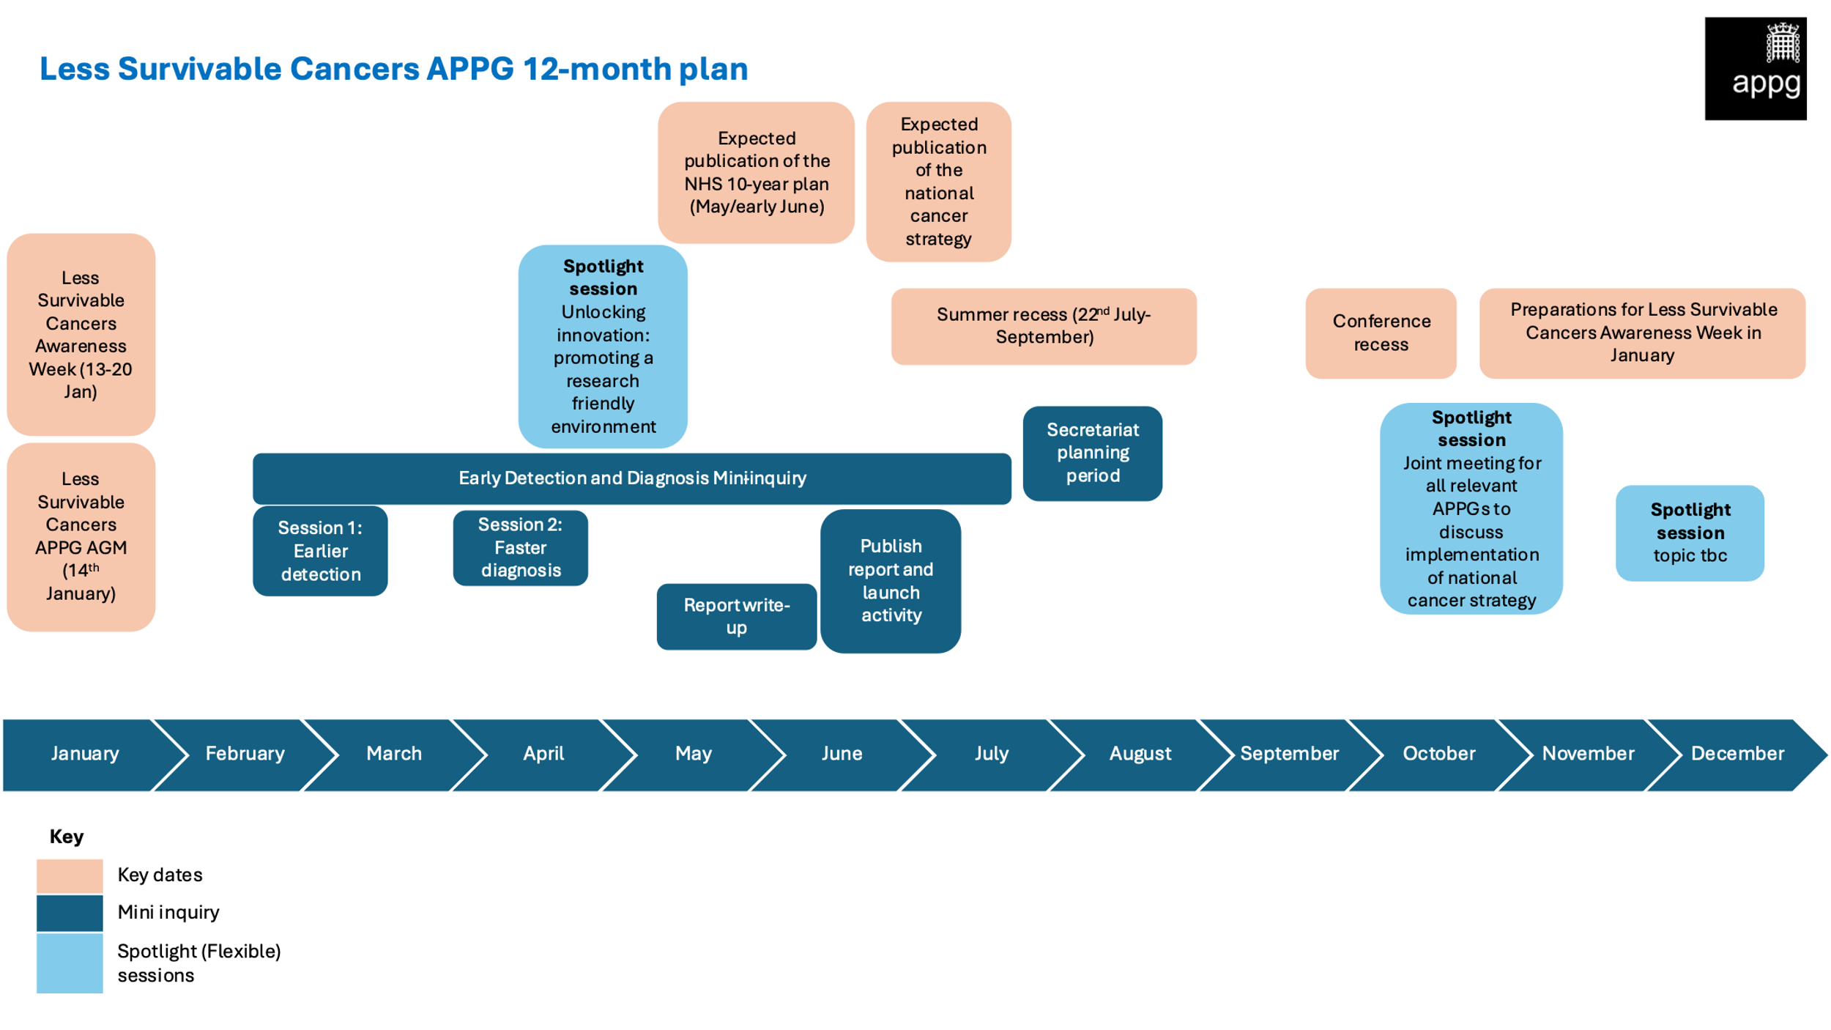

**APPG on Less Survivable Cancers**

**Proposed Work programme 2025/26**

**Mini-inquiry into Earlier Detection and Faster Diagnosis**

**Purpose**

The Secretariat proposes that the APPG launches a mini-inquiry into earlier detection and faster diagnosis of the less survivable cancers. **By focusing on this topic, the inquiry will cover some of the fundamental barriers to improving survival rates and ensuring that patients have access to better treatment and care.**

**The purpose of this inquiry is to:**

* Enable members to hear from experts, healthcare professionals, patients and officials to identify practical steps for earlier detection and faster diagnosis.
* Produce a set of practical recommendations to improve earlier detection and faster diagnosis of
* the less survivable cancers.
* Raise awareness of the less survivable cancers in Parliament to ensure they are a priority in the 10-year Health Plan and National Cancer Strategy.

**Timelines and Structure (End of Feb-June/July)**

We propose that the APPG hosts **two closed meetings** on the challenges facing earlier detection, and innovation in diagnosis. Following these sessions, the Group will **publish a mini-inquiry report** outlining the key findings and recommendations.

**Session 1: The challenges facing earlier detection of the less survivable cancers – screening and referral (Feb - March)**

This session is an opportunity for parliamentarians to understand the challenges to earlier detection and what **systemic changes** are needed to improve outcomes for the less survivable cancers. Examples will include surveillance and screening in high-risk groups as well as innovations in onward referral of people presenting with symptoms.

**Session 2: Innovating faster diagnosis of the less survivable cancers (April)**

MPs will have the opportunity to hear from leading researchers who are exploring innovative methods to accelerate faster diagnosis of the less survivable cancers. We will also invite healthcare professionals and NHS and DHSC officials to discuss how these technologies can be integrated into patient pathways.

**Report write-up (May- June)**

The Group will draft a mini-inquiry report outlining its findings and recommendations to enhance earlier detection and faster diagnosis. We will aim to secure media coverage surrounding the launch to raise awareness of the recommendations at a crucial time, as the Government cancer strategy will likely be being drafted during this period.

**“Spotlight” sessions:**

These sessions can take place throughout the year as an opportunity for members to hear more about issues of most importance to them. We propose **3 spotlight sessions.**

* Session 1: Unlocking innovation: promoting a research-friendly environment for the less survivable cancers
* Session 2: Joint meeting of relevant APPGs to discuss implementation of national cancer strategy with DHSC/NHS (i.e. APPGs on brain tumours, liver disease etc.)
* Session 3: Topic TBC

**Ideas for session 3 and/or future sessions:**

* Promoting greater access to treatment and care
* Health inequalities and their impact on the less survivable cancers
* Palliative care and the less survivable cancers
* Regional inequalities and the less survivable cancers
* Deep-dive sessions into specific cancers (e.g. the specific challenges associated with detecting brain tumours)
* The power of prevention in tackling the less survivable cancers