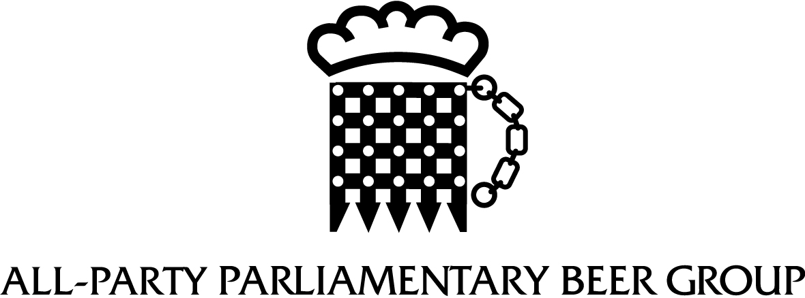

2024 Inaugural Meeting
16.00, Monday 29th July 2024
Room W3, Westminster Hall

MINUTES
Those participating:

Bayo Alaba MP  Tonia Antoniazzi MP  Lord Bilimoria  Jacob Collier MP  Lord Evans of Rainow  Tan Dhesi MP  Mary Glindon MP  Claire Hughes MP  Michael Wheeler MP  Mike Wood MP | Rita King, Honorary Secretary, All Party Parliamentary Beer Group  Rhea Porter (Office of Tonia Antoniazzi MP)

1 | Apologies for Absence  The Honorary Secretary reported that apologies for absence had been received from:

Bob Blackman MP  Lord Dholakia  Baroness Hayter of Kentish Town  Sharon Hodgson MP  Richard Holden MP  Ben Lake MP | Baroness McIntosh of Pickering  Lord McNicol of West Kilbride  Greg Smith MP  Jamie Stone MP  Pete Wishart MP

2 | Election of Honorary Officers and Executive Committee of the Group to serve until the next Annual General Meeting.  The Honorary Secretary paid tribute to the previous Chair of the Beer Group, the Rt Hon Alun Cairns, for his support and championing of the beer and pub sectors. It was also noted that Lord Evans of Rainow would take on the Honorary President position from the Rt Hon Nigel Evans.  The following Officers were appointed:

Chair  Deputy Chairs |  | Tonia Antoniazzi MP  Greg Smith MP  Pete Wishart MP  Jamie Stone MP | Labour  Conservative  SNP  Lib Dem
3 | Activities Report  At the request of the Chair, the Honorary Secretary reported on the events held by the Beer Group over the past year, which were as follows:  Welsh Beer Tasting, Westminster (Sept 2023)  Party Conference Receptions at the Conservative Party Conference in Manchester (Sept 2023) and the Labour Party Conference in Liverpool (Oct 2023)  A Celebration of the History and Heritage of Brewing, Westminster (Nov 2023)  Christmas Reception, Westminster (Dec 2023)  Chairman’s Dinner, Central London (Jan 2023)  PubAid Community Hero Awards, Westminster (March 2023)  Annual Beer Awards Dinner, One Great George Street, Westminster (May 2023)  Further events were planned for the autumn, including:  Party Conference Receptions:  Labour Party Conference, Liverpool (23rd Sept 2024)  Conservative Party Conference, Birmingham (30th Sept 2024)  A Celebration of Pubs at the Heart of their Local Communities, Westminster (5th Nov 2024)  Christmas Reception, Westminster (4th Dec 2024)  It was also planned to re-schedule a Roundtable on low and no alcohol which had been due to take place in June but was cancelled following the announcement of the General Election. Beer was the leading category in this growth of low and no products.  The Chair said that the Beer Group was a very active and popular All-Party Group. She encouraged attendees to engage with pubs and brewers in their local constituencies – MPs have an average of 2 breweries and 80 pubs in their constituencies, and the sector made a valuable contribution to the local employment and economy, and the local community. The Honorary Secretary could support with local visits if MPs were finding it difficult to make contact with operating companies, or would like to find out who owned particular pubs in their area.  Mary Glindon MP enquired whether the Group held brewery visits and whether these could also take place outside London. The Honorary Secretary confirmed that the Group had traditionally held visits around London within easy reach of Westminster, but there was no reason why visits could not be held regionally, with a number of local MPs invited to take part.  There followed a general discussion about members’ local engagement with the sector to date. The economic and social importance of the sector was widely acknowledged. The Honorary Secretary highlighted the Guest Beer programme in the Strangers’ Bar which enabled MPs to nominate a local brewer from their constituency to have their beer on tap in the bar. Further information would be circulated to members about this.  The Chair would hold further discussions with the Honorary Secretary on activities over the coming year.
6 | Financial Accounts.  The Beer Group Accounts were presented by the Honorary Secretary and approved; proposed by Lord Evans and seconded by Mary Glindon MP.
7 | Any Other Business.  There was no other business. The Chair thanked members for attending the Inaugural Meeting of the All-Party Parliamentary Beer Group.

Rita King, Honorary Secretary
29th July 2024

